**DIGITAL MARKETING**

**ASSIGNMENT- 1**

Create a blog or website using Blogspot and WordPress. Customize the theme design and post new article with 500 words.

|  |  |
| --- | --- |
| Name | S.S.Anila |
| Reg. No | 960220106020 |
| NM ID | 1A0DACA62753137AB46455B375054197 Anila |
| Team ID | NM2023TMID02623 |

**Blogspot:**

[**https://nilaaarifashion.blogspot.com/2023/08/nila-aari-fashion.html?m=1**](https://nilaaarifashion.blogspot.com/2023/08/nila-aari-fashion.html?m=1)

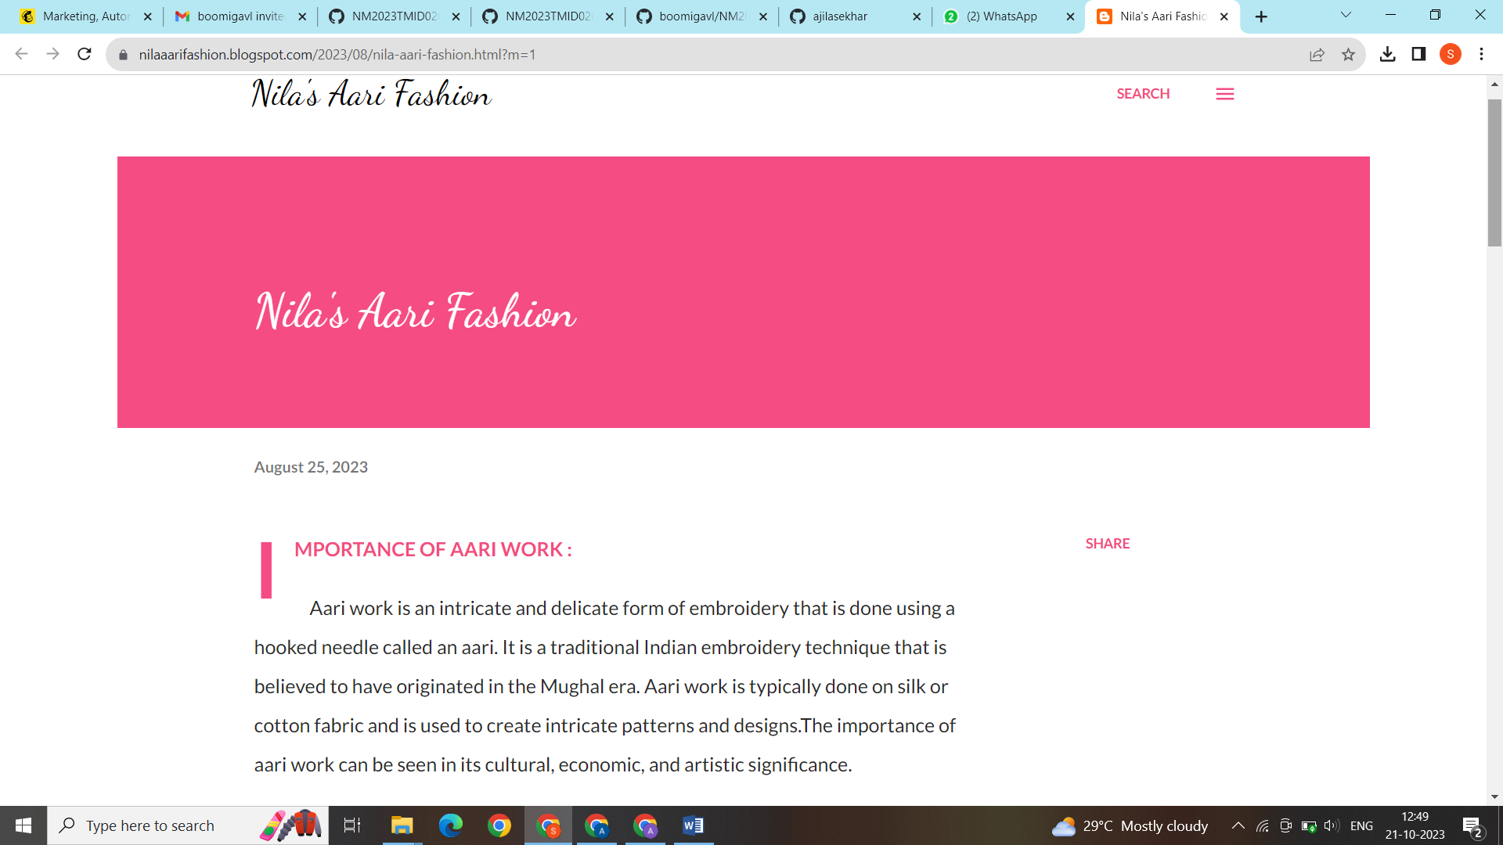

**Wordpress:**

[**https://nilaarifashion22.wordpress.com/2023/10/08/nilas-aari-fashion/**](https://nilaarifashion22.wordpress.com/2023/10/08/nilas-aari-fashion/)

